**DAA – Assignment no: 04**

Write a Python program to solve a 0-1 Knapsack problem using dynamic programming or branch and bound strategy.

Input:

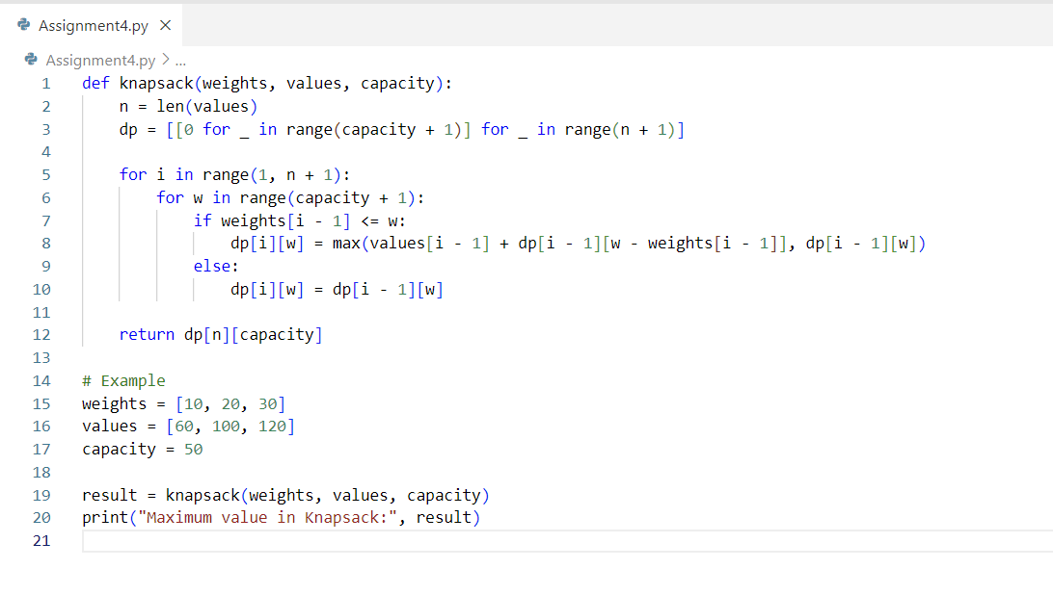

Output:

